Toledo Gem & Rockhound Club Waiver & Policy Acknowledgement
Important: We must have a signed and dated copy of this waiver on file to be a valid member.
TGRC Waiver: As a condition of membership, and in consideration of any mineral collecting, use of facilities, equipment, and other educational opportunities available to me/my family as a club member, I hereby agree to hold the Club and its officers, directors, committee members and agents harmless, and to indemnify them against any loss and claims arising from my or my family’s participation in Club activities
Term of membership and Dues. TGRC memberships run from January 1 to December 31 of each year. New members joining at the September show will have their dues credited though the end of the following year. Your membership includes applicable Lucas County, Ohio Sales Tax.
Name (Print) ______________ ________

Date _____/_____/__________

Signature _________________________

WHAT GROUPS ARE YOU
INTERESTED IN? (see descriptions)

___ Beaders
___ Faceters
___ Field Trips
___ Metal Crafters, Mineral/Fossils
___ Annual Show Team

FACETERS
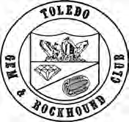
Faceting is the process of putting many flat, highly polished surfaces on a gemstone. Mem- bers of this group meet
to learn, view each other's work and to discuss new patterns.

BEADERS
Beading provides members the oppor- tunity to learn to make jewelry and other fashion items from regular beads, seed beads, and pearls. Our methods include loom weaving, embroidery, and stringing. Patterns are provided and project books are available. No equipment is necessary and basic supplies are provided to the novice. The EXTREME BEADERS are for advanced skills.

METALCRAFTERS
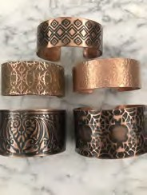
Make jewelry. New members are given instruction in the basic fabrication skills; sol- dering, sawing, and filing. After that, mem- bers branch out and develop their own styles. Current inter- ests include piercing, precious metal clay, woven chaining, and
general silversmithing. There is always someone who can offer a new technique or opinions on problems that need solu- tions.

FUTURE ROCKHOUNDS OF
AMERICA (Juniors)
www.RockyReader.com
Facebook: Toledo Gem and Rockhound Club
Instagram: Toledo Gem and Rockhound Club
Education is our focus and the FRA is our youth group focused on the Earth
Sciences. For ag- es 7 to 17 yrs. We follow the Ameri- can Federation of Mineralogical So- cieties’ curricu- lum. Our leaders are educated and have background checks. Parents do have to ac- company their children to these activities.

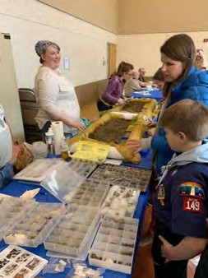
ANNUAL SHOW TEAM
The TGRC hosts one of the largest gem and jewelry shows in the
Midwest. Join a team dedicated to plan- ning and executing an exciting 3-day show featuring hands-on learning and vendors from across the Globe.

FIELD TRIPS
Help plan and participate in trips to inter- esting geological sites. At many, you can collect rocks that can then be made into gems, set in jewelry or displayed as specimens.

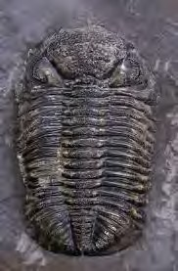
MINERALS/FOSSILS
Share knowledge and dis- cover new geologic speci- mens with other club mem- bers. We are in the heart of Devonian fossil country.

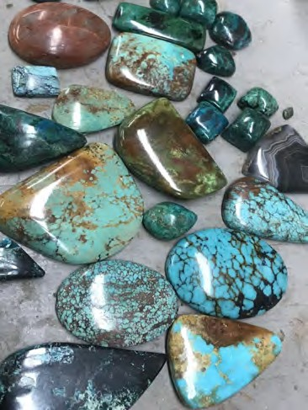
JOIN US!
Hands-on training in minerals, fossil ID, gemstone making, beading, faceting and
jewelry fabrication
Toledo Gem &
Rockhound Club

Join others who love all things rock!
We are an active and diverse group- from educators to artists, collectors
to geology enthusiasts. We host ed- ucational meetings, field trips, shows and offer hands-on classes.

There are many ways to enjoy rock related hobbies with our club. Sign up for an introductory class in gem- stone polishing and/or faceting, jewelry fabrication, wire wrapping or beading. Come to our well-equipped Craft Center and work on a variety of equipment in an atmosphere that allows progress at your own speed and respect for your particular style. Join a regular work group to learn from others and share your experi- ence. Meet together to lean more
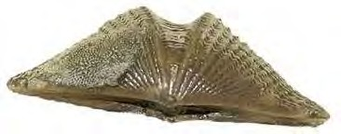
about fos- sils, miner- als and local geology.

We do need interested volunteers to help with public education, moderating work sessions, caring for equipment and hosting our big Jewelry, Gem and Mineral Show in September.

Join us as we spread the word that
The Toledo Area Rocks!

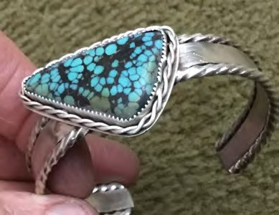

Organized in 1962, the TGRC was in- corporated as a not for profit
organization in 1966 for the purpose of promoting interest and increasing knowledge in the fields of Mineralogy, Geology and the Lapidary Arts.

Our Craft Center is located at
2453 Tremainsville Road,
Toledo, OH 43613.

Some of our work groups:

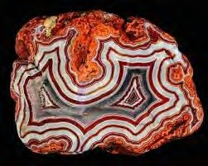
GEMCRAFTERS
A working group that allows mem- bers to develop or expand their lapi- dary skills. Focused mainly on the cut- ting and polishing
of cabochons, the group also supplies in- formation on handling of different types of cutting materials, orientation, channel in- lay, carving, etc.

(CONTINUED ON BACK)

NAME (Please print legibly)
Fill out, clip and mail. Don’t forget the back side of this form!

SPOUSE (family memberships)

CHILDREN and birth date (Family Mem)

ADDRESS

CITY STATE ZIP CODE PHONE
EMAILS (very important!)

Mailing Address
PO Box 13268
Toledo OH 43613

Membership Category New__Renew __
___ Individual $32.33 with tax
___Family (live together) $53.88 with tax

___ Grandparents $53.88 with tax
___ Youth $16.17 with tax
Please complete the reverse side.
OVER

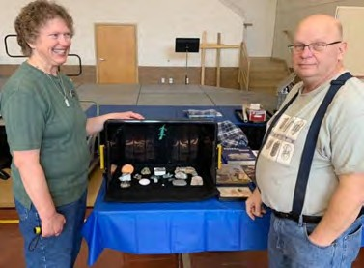
Benefits of
Membership
- Emailed monthly Rocky Reader
newsletter & ability to advertise in it
- Member meetings and right to vote on club business
- Discounted rate for workshops and classes
- Extended hours at the Craft Center
- Hands-on introductory classes in cabochon making, faceting and jewelry making for the exclusive membership rate
- Reduced admission to the annual Jewelry, Gem and Mineral Show in Sept.
- Family memberships grant access to our juniors group– the Future
- Rockhounds of America
- Access to the membership directory to connect you with local experts and those who share your interests in all things rock, bead, gem, fossil, miner- al and metal crafting
- Annual holiday party

